**Pizza Sales SQL Queries**

1. **KPIs**
2. **Total Sales**

select sum(total_price) as Total_revenue from pizza_sales;

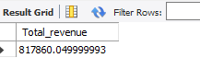

1. **Average Order Value**

select sum(total_price)/Count(distinct order_id) as Avg_Order_Value from pizza_sales;

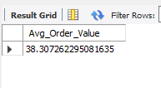

1. **Total Pizzas Sold**

select Sum(quantity) as Total_pizzas_sold from pizza_sales;

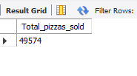

1. **Total Orders**

select count(distinct order_id) as Total_Orders from pizza_sales;

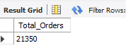

1. **Average Pizzas per Order**

select sum(quantity)/count(distinct order_id) as Average_Pizza_Per_Order from pizza_sales;

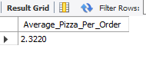

1. **Charts Requirement**
2. **Daily Trend for Total Orders**

SELECT

DAYNAME(STR_TO_DATE(order_date, '%d-%m-%Y')) AS Order_Day,

COUNT(DISTINCT order_id) AS Total_Orders

FROM

pizza_sales

GROUP BY Order_Day

ORDER BY FIELD(Order_Day,

'Sunday',

'Monday',

'Tuesday',

'Wednesday',

'Thursday',

'Friday',

'Saturday');

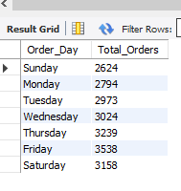

1. **Monthly Trend for Total Orders**

SELECT

MONTHNAME(STR_TO_DATE(order_date, '%d-%m-%y')) AS Order_Month,

COUNT(DISTINCT order_id) AS Total_Orders

FROM

pizza_sales

GROUP BY Order_Month

ORDER BY Total_Orders desc;

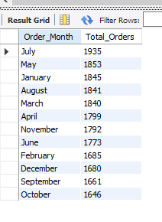

1. **Percentage of Sales by Pizza Category**

SELECT

pizza_category,

SUM(total_price) * 100 / (SELECT

SUM(total_price)

FROM

pizza_sales) AS Percentage_Sales_per_Category

FROM

pizza_sales

GROUP BY pizza_category;

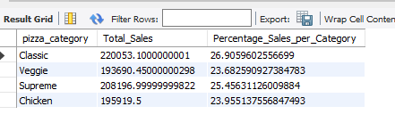

1. **Percentage of Sales by Pizza Size**

SELECT

pizza_size, SUM(total_price) as Total_Sales,

SUM(total_price) * 100 / (SELECT

SUM(total_price)

FROM

pizza_sales) AS Percentage_Sales_per_Category

FROM

pizza_sales

GROUP BY pizza_size;

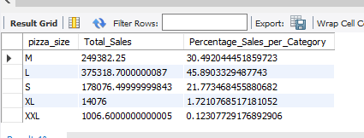

1. **Total Pizzas Sold by Pizza Category**

select pizza_category, sum(quantity) as Total_qty_sold from pizza_sales group by pizza_category;

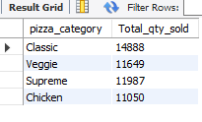

1. **Top 5 Best Sellers by Revenue, Total Qty and Total Orders**
2. **By Revenue**

select pizza_name, Sum(total_price) as Total_Revenue from pizza_sales group by pizza_name order by Total_Revenue desc limit 5;

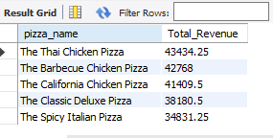

1. **Total Qty**

select pizza_name, Sum(quantity) as Total_Qty from pizza_sales group by pizza_name order by Total_Qty desc limit 5;

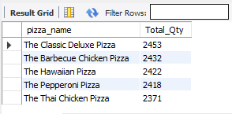

1. **Total Orders**

select pizza_name, count(distinct order_id) as Total_Orders from pizza_sales group by pizza_name order by Total_Orders desc limit 5;

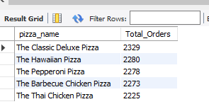

1. **Bottom 5 Worst Sellers by Revenue, Total Qty and Total Orders**
2. **By Revenue**

select pizza_name, Sum(total_price) as Total_Revenue from pizza_sales group by pizza_name order by Total_Revenue limit 5;

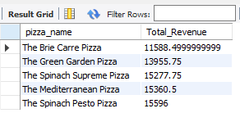

1. **Total Qty**

select pizza_name, Sum(quantity) as Total_Qty from pizza_sales group by pizza_name order by Total_Qty limit 5;

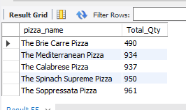

1. **Total Orders**

select pizza_name, count(distinct order_id) as Total_Orders from pizza_sales group by pizza_name order by Total_Orders limit 5;

